Background:

KCI has experienced feedback from many sources on different occasions stating that getting from terminal to terminal is slow and inefficient. After asking voters what the biggest concern for KCI is, the response has been **convenience** and **cost**. The city has been offered by several major airline investors in hopes of rebuilding or renovating KCI, and they fear that if KCI does not act quickly their major airline investments will be taken elsewhere. With this pressure, KCI Aviation director Patt Klein has been looking into several different options, but they have been boiled down to: Build a new terminal, or renovate the old ones. The current options are outlined in *Figure 1*. *Figure 2* also shows the hope of a single terminal design.

*Figure 1.*

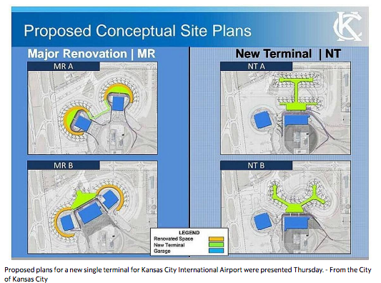

*Figure 2.*

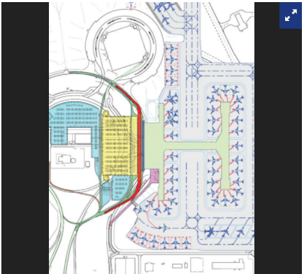

The benefit to acting sooner than later is that financial support from major investors will be available and the cost will only be reflected on the users of KCI which are about 88% non-local traffic.